CS 255 System Design Document Template

UML Diagrams

UML Use Case Diagram
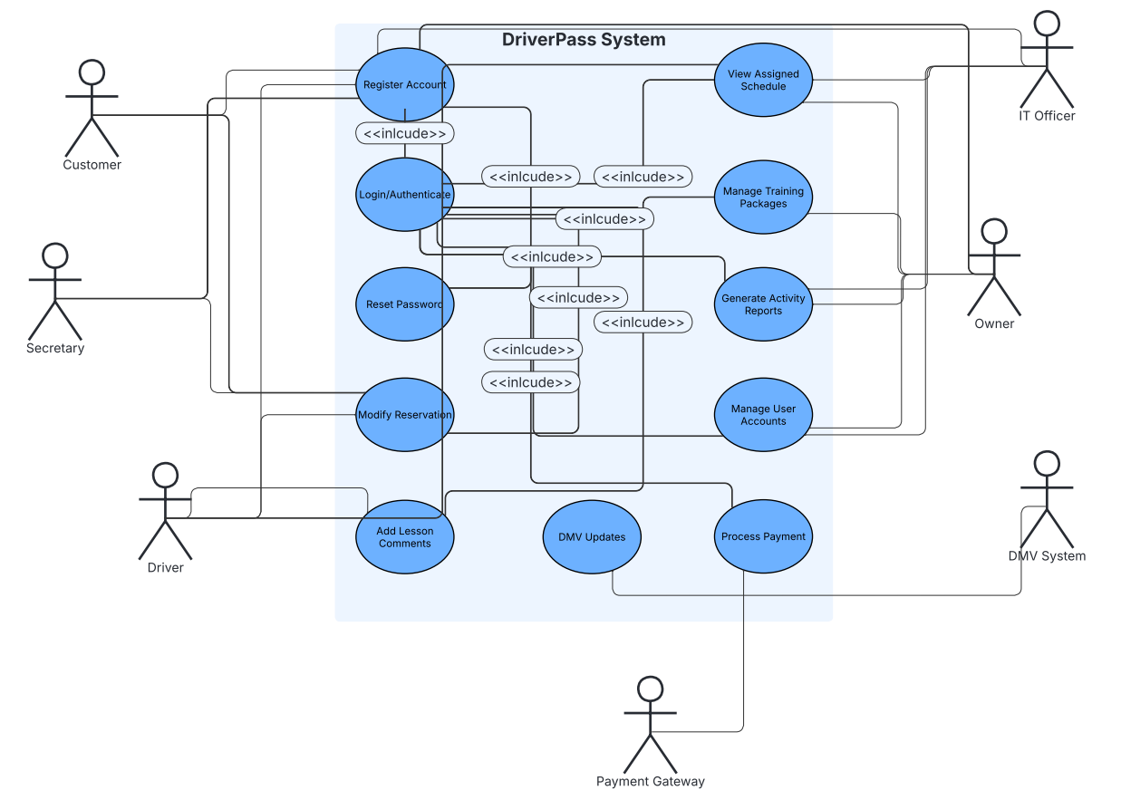

UML Activity Diagrams
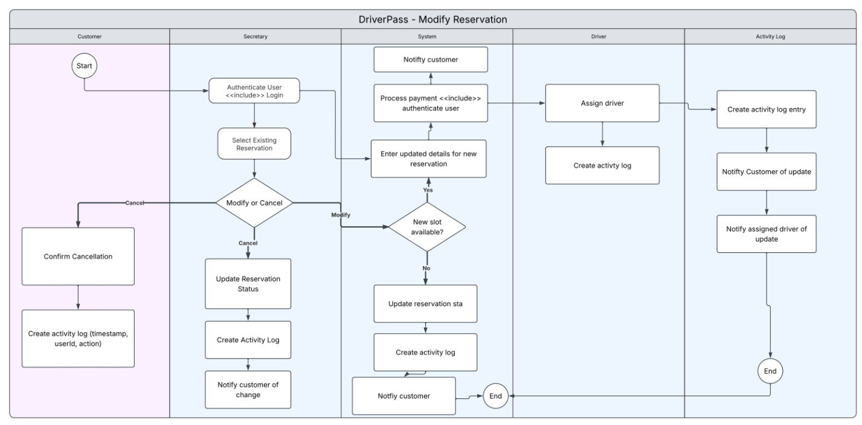

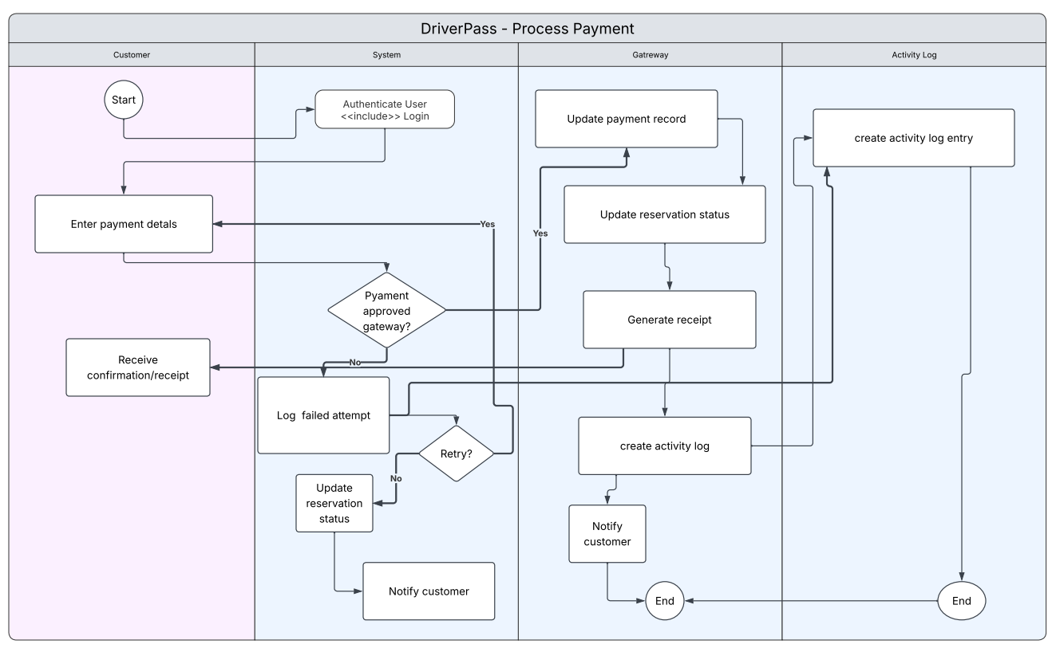

UML Sequence Diagram
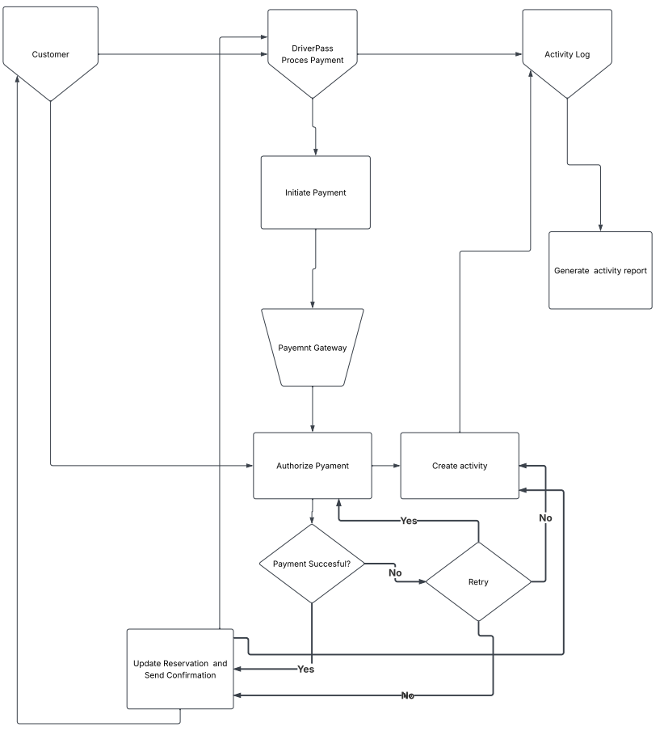

UML Class Diagram
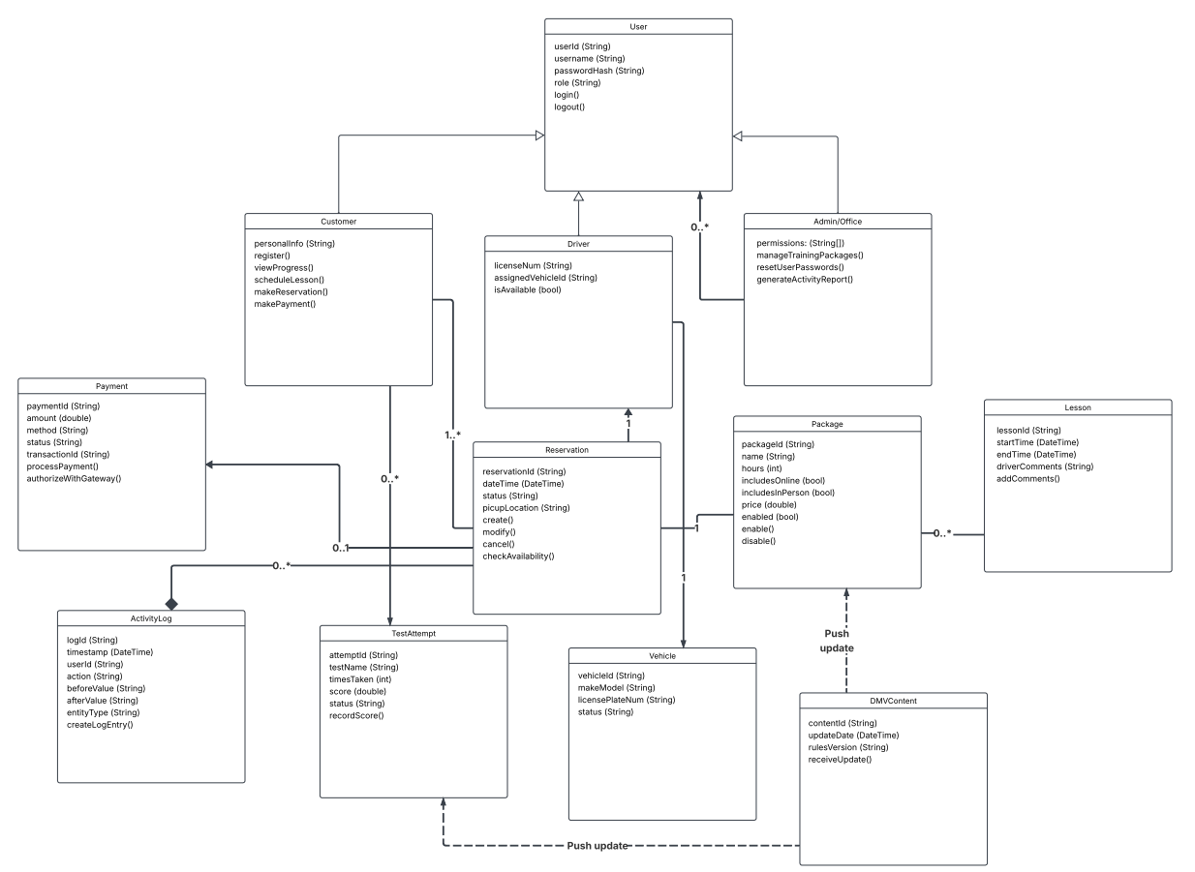

Technical Requirements
To meet the requirements set by the Client this system must be delivered as a secure, cloud-hosted web application that is accessible from any modern device with access to the internet, with a strict read-only offline mode for downloading reports. Infrastructure requirements should focus on a scalable cloud platform, a central relational database for all persistent data, object storage for any uploaded documents, and automated backup with point-in-time recovery. Networking must include HTTPS/TLS, a Web Application Firewall, rate limiting on authentication endpoints, secure API gateways for the payment processor and DMV updates. The system must enforce role-based access control at the infrastructure level so that user permissions are enforced before data is touched, and each action must generate a timestamped activity report with before/after values and user id.
No specialized hardware is needed since this will be cloud hosted, other than the 10 training vehicles. Hardware requirements will be limited to any reasonably modern computer, smartphone, or tablet. Software requirements include a modern backend with a REST or GraphQL API layer. The frontend must be a responsive web app. All credit card data must be tokenized and never stored or transmitted on DriverPass servers. The system must allow users with admin level access to reset users passwords and enable/disable packages.

